**VPN Configuration (2)**

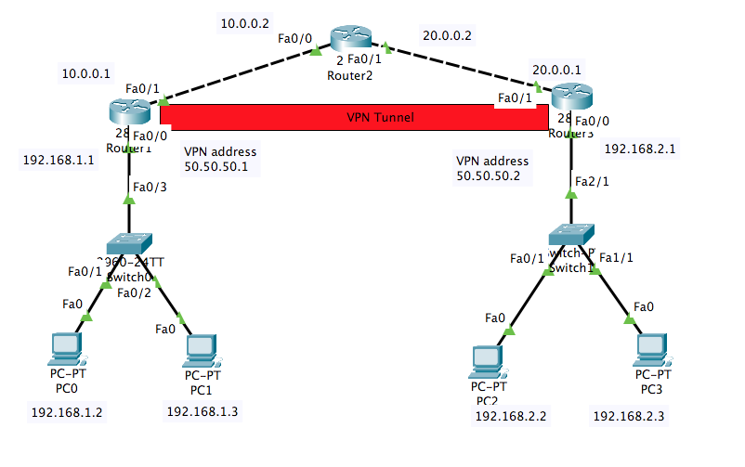

**Step 1**: Build network topology as shown in the above figure. Use Router 2811 for Router1, Router2, Router3.

**Step 2**: Setup IP addresses for each device

|  |  |  |  |  |
| --- | --- | --- | --- | --- |
| Device | Interface | IP address | Subnet Mask | Gateway |
| PC0 | Fa0 | 192.168.1.2 | 255.255.255.0 | 192.168.1.1 |
| PC1 | Fa0 | 192.168.1.3 | 255.255.255.0 | 192.168.1.1 |
| PC2 | Fa0 | 192.168.2.2 | 255.255.255.0 | 192.168.2.1 |
| PC3 | Fa0 | 192.168.2.3 | 255.255.255.0 | 192.168.2.1 |
| Router1 | Fa0/0 | 192.168.1.1 | 255.255.255.0 | NA |
| Fa0/1 | 10.0.0.1 | 255.255.255.0 | NA |
| Router2 | Fa0/0 | 10.0.0.2 | 255.255.255.0 | NA |
| Fa0/1 | 20.0.0.2 | 255.255.255.0 | NA |
| Router3 | Fa0/0 | 192.168.2.1 | 255.255.255.0 | NA |
| Fa0/1 | 20.0.0.1 | 255.255.255.0 | NA |

**Step 3**: Configure default routing

Router1:

Router>enable

Router#config t

Router(config)#ip route 0.0.0.0 0.0.0.0 10.0.0.2

Router3:

Router>enable

Router#config t

Router(config)#ip route 0.0.0.0 0.0.0.0 20.0.0.2

**Step 4**: Check the connection by pinging each other between R1 and R3

Router1:

Router#ping 20.0.0.1

Router3:

Router#ping 10.0.0.1

**Step 5**: Create VPN tunnel

Router1:

Router#config t

Router(config)#interface tunnel 1

Router(config-if)#ip address 50.50.50.1 255.255.255.0

Router0(config-if)#tunnel source fa0/1

Router0(conig-if)#tunnel destination 20.0.0.1

Router0(config-if)#end

Router3:

Router#config t

Router(config)#interface tunnel 1

Router1(config-if)#ip address 50.50.50.2 255.255.255.0

Router1(config-if)#tunnel source fa0/1

Router1(config-if)#tunnel destination 10.0.0.1

Router1(config-if)#end

**Step 6**: Check the VPN connection by pinging each other for Router0 and Router1

Router1:

Router#ping 50.50.50.2

Router3:

Router#ping 50.50.50.1

**Step 7**: Create routing for PCs to connect over VPN

Router1:

Router(config)#ip route 192.168.2.0 255.255.255.0 50.50.50.2

Router3:

Router(config)#ip route 192.168.1.0 255.255.255.0 50.50.50.1

**Step8**: Check the connection from PC0 to PC2, from PC0 to PC3, from PC1 to PC2, from PC1 to PC3 by pinging each other.

PC0:ping 192.168.2.2

PC0:ping 192.168.2.3

PC1:ping 192.168.2.2

PC1:ping 192.168.2.3

*Submit the screenshots of ping results for step 4, 6, 8 together with your packet tracer file.